A Project Report on
Maze Runnner Game
Submitted in partial fulfillment of the requirement of
PROJECT-II
(BIT105CO)
BACHELOR OF INFORMATION TECHNOLOGY
Submitted to


Purbanchal University Biratnagar, Nepal

Submitted By

Bipin tamang ( )
Dikshant khanal ( )
Soviet Khaling Rai ( )

KANTIPUR CITY COLLEGE
Putalisadak, Kathmandu
December 2025

A Project Report on
Maze Runner Game
Submitted in partial fulfillment of the requirement of
PROJECT-II
(BIT105CO)
BACHELOR OF INFORMATION TECHNOLOGY

Submitted to
Purbanchal University Biratnagar, Nepal

Submitted By
Bipin tamang ( )
Dikshant khanal ( )
Soviet Khaling Rai ( )

Project Supervisor
Mr. Kiran Khanal
Senior Assistant Professor

KANTIPUR CITY COLLEGE
Putalisadak, Kathmandu
December 2025

Table of Contents
ABSTRACT iii
ACKNOWLEDGEMENTS iv
PREFACE iv
DECLERATION v
SUPERVISOR’S APPROVAL vi
CERTIFICATE FROM DEPARTMENT vii
Introduction 1
1.1 Overview 1
1.2 Problem Statement 1
1.3 Objective 1
1.4 Features 2
1.5 Significance 2
1.6 Scope and Limitations 2
1.7 Organization of the Document 3
2. Literature Review 4
2.1 System 1 Overview – Voting System (C Language) 4
2.1.1 System 1 Pros 4
2.1.2 System 1 Cons 4
2.2 System 2 Overview – List Application System (C Language) 5
2.2.1 System 2 Pros 5
2.2.2 System 2 Cons 5
2.3 System 3 Overview – Quiz Game (Our Project) 6
2.3.1 System 3 Pros 6
2.3.2 System 3 Cons 6
3 Methodology 7
3.1 Software Development Life Cycle 7
3.2 Technologies and Tools Used 9
3.2.1 Programming Language Used 9
3.2.2 Database Used 9
3.2.3 Software Used 9
3.2.4 Integrated Development Environment (IDE) 10
3.3 Assignment of Roles and Responsibility 10
4 System Analysis 11
4.1 Requirements Analysis 11
4.1.1 Requirement Gathering 11
4.1.2 Functional Requirements 12
4.1.3 Non-Functional Requirements 13
4.2 Gantt Chart 14
5. System Design 15
5.1 System flow Diagram and Algorithm 15
5.1.1. System Algorithm 15
5.1.2. System Flowchart 16
6 System Development and Implementation 17
6.1 Programming Platform 17
6.2 Operating Environment 17
7 Testing and Debugging 18
7.1 Tools Used in Testing 18
7.2 Test Cases 19
8 Conclusion 20
9 References 21

LIST OF FIGURES
Figure 3.1 Waterfall Model………………………………………………….….16
Figure 4.2 Gantt chart………………………………………………….………..21
Fig 5.1.2 System Flow Diagram…………………………………………….…..23

ABSTRACT

This project report presents a console-based "Maze Runner Game" developed using the C++ programming language. The game is designed to offer an interactive and engaging experience for users, testing their knowledge across multiple subjects. Implemented in a structured and modular format, the program features question selection, score tracking, file handling for high scores, and a user-friendly interface. This project demonstrates the practical application of basic programming concepts such as conditionals, loops, functions, and file input/output. The entire development process was carried out using Visual Studio Code. The goal of this project was to reinforce programming fundamentals while building a functional and enjoyable entertainig game.

ACKNOWLEDGEMENTS

We would like to express our sincere gratitude to our supervisor, Mr. Kiran Khanal, for his continuous guidance, support, and encouragement throughout the duration of this project. His insightful feedback greatly enhanced the quality of our work.
We are thankful to Kantipur City College and its faculty members for providing us with the resources and environment needed to complete this project. We are also grateful to our fellow classmates for their support and collaboration.
This project, titled "Maze Runner Game" was collaboratively developed by Soviet Khaling Rai, Bipin tamang, and Dikshant khanal. All members actively participated in the design, development, and documentation of the system.
Sincerely,
Bipin tamang
Dikshant khanal
Soviet Khaling Rai

PREFACE

This report documents the development of a console-based application titled "Maze Runner Game" using the C++ programming language. The primary objective of this project was to implement a simple yet educational game that helps users test their general knowledge through a series of questions.
The project offered hands-on experience in software development, from planning and designing to coding and debugging. We utilized Visual Studio Code as our IDE and developed the game on the windowsOS platform. Key programming concepts such as modularization, input validation, loops, and file handling were explored throughout the development process.
We hope this report serves as a helpful reference for students interested in learning how to build a console-based application in C++.

DECLERATION

We hereby declare that this project report titled "Maze Runner Game " submitted as a partial fulfillment of the Bachelor's program, is an original work carried out by us under the supervision of Mr. Kiran Khanal. This report has not been submitted for the award of any degree or diploma in this or any other institution or university.
Proper acknowledgment has been given wherever external sources have been used.
Bipin tamang ( )
Dikshant khannal ( )
Soviet Khaling Rai ( )

Date: december 2025

SUPERVISOR’S APPROVAL

This is to certify that the major project entitled Maze Runner Game undertaken and demonstrated by:Bipin tamang, Dikshant khannal and Soviet Khaling Rai has been successfully completed under my supervision as a partial fulfillment of the requirements for the degree of Bachelor in Information Technology (BIT, 1st Semester) under Purbanchal University.
During my supervision, I found the students to be hardworking, competent, and capable of handling professional tasks related to this field in the future.

_______________
Mr. Kiran Khanal
Project Supervisor
[Senior Assistant Professor ]
Date: december 2025

CERTIFICATE FROM DEPARTMENT

Following the Supervisor’s Approval and Examiners’ Acceptance, the project entitled Maze runner Game submitted by Bipin tamang ,Dikshant khannal and Soviet Khaling Rai as a partial fulfillment of the requirements for the degree of Bachelor in Information Technology (BIT, 1st Semester) under Purbanchal University, has been officially awarded by this certificate.
I wish the students all the best for their future endeavors.

____________ ______________
Saroj Pandey Rubim Shrestha
HoD Project Coordinator
Department of IT Department of IT

Introduction

Overview
The Maze Runner Game is a simple computer game where a player must find a way through a maze from the start point to the finish point. It is designed to test the player's problem-solving skills, patience, and memory. The player faces challenges like dead-ends and confusing paths. This game can be developed using programming languages like C++ with basic graphics or console output.

Problem Statement

Beginner programmers often find it difficult to apply theoretical programming and OOP concepts in real-world applications. There is a need for simple projects that demonstrate practical implementation of logic and user interaction. In a maze game, challenges such as handling user input, managing collisions with walls, maintaining boundaries, and implementing correct navigation logic must be solved. This project addresses these challenges by developing a Maze Runner Game that clearly demonstrates these concepts in an easy and understandable manner.

1.3 Objective
The primary objective of this project is to design and implement a mzae ruunner game in C++. The specific goals include:
- To design and develop a simple Maze Runner Game.
- To apply basic programming and OOP concepts in a real-world project.
- To implement user input handling and movement logic.
- To manage collisions and boundaries within the maze.
- To improve logical thinking and problem-solving skills.

1.4 Features

The Maze Runner Game includes a simple maze layout where the player moves from a start point to an end point. The player can control movement using basic input keys. The game prevents the player from passing through walls and allows movement only through valid paths. The game ends when the player successfully reaches the goal.

1.5 Significance

This project is significant because it helps beginners understand how programming concepts are used in real applications. It provides hands-on experience with logic building, user interaction, and structured coding. The project also demonstrates the practical use of OOP concepts, making learning more interesting and effective.

1.6 Scope and Limitations
The scope of this project is limited to a single-player maze game with simple rules and logic. The project focuses on basic movement and navigation within a fixed maze. However, the system can be extended in the future by adding multiple levels, scoring systems, or graphical enhancements.The Maze Runner Game has certain limitations. It does not include advanced graphics, sound effects, or animations. The maze size and difficulty are limited, and the game does not support multiplayer or artificial intelligence features. The user interface is simple and basic.

1.7 Organization of the Document
This project document is organized into different sections to explain the Maze Runner Game in a clear and simple manner. It starts with an introduction and problem statement that describe the purpose and basic idea of the project.Next, the document explains the objectives, features, significance, scope, and limitations of the project to help the reader understand what the system does and what it does not cover. After that, the design and implementation section describes how the maze, player movement, and game logic are developed.
Finally, the document ends with the result and conclusion, which summarize the project outcome and suggest possible improvements for the future.

2. Literature Review
This section reviews previously developed console-based games and applications in the C programming language that inspired the creation of our Quiz Game. It analyzes their strengths and limitations to demonstrate how this project builds upon and improves existing ideas, while staying within the console environment.

2.1 System 1 Overview – Voting System (C Language)
The Voting System is a console-based application developed in C that allows users to vote among a list of candidates. It features simple input handling, vote counting, and display of results. This system was one of our early explorations into structured programming, file handling, and menu-driven interfaces.

2.1.1 System 1 Pros
- Straightforward logic and easy to understand
- Good for practicing menu-based navigation and file handling

2.1.2 System 1 Cons
- Lacks interactivity and real-time decision-making
- Limited in user engagement and not designed as a game.

2.2 System 2 Overview – List Application System (C Language)
The List Application System is a basic console application used to manage lists, such as storing names, numbers, or tasks. It demonstrated use of data structures like arrays and structs, and offered CRUD (Create, Read, Update, Delete) operations via a menudriven interface.

2.2.1 System 2 Pros
- Helps understand structured data storage using arrays and structs
- Encourages logical flow and user input validation

2.2.2 System 2 Cons
- Not designed for entertainment; purely functional
- No dynamic gameplay or scoring mechanism

2.3 System 3 Overview – Quiz Game (Our Project)
After working on the Voting and List Application systems, we developed the Quiz Game using C to provide a more interactive and enjoyable console-based experience. This game asks users multiple-choice questions, tracks scores, offers feedback, and can save or display high scores. It blends structured programming with fun, learningoriented gameplay.

2.3.1 System 3 Pros
- Interactive and educational gameplay suitable for all users
- Console-based and lightweight, runs on any system with C support
- Features scoring system and user-friendly menu navigation
- Encourages learning and quick thinking under time constraints (optional)

2.3.2 System 3 Cons
- Limited to text-based interface without multimedia support
- No multiplayer or online capabilities
- Static question sets unless manually updated

3 Methodology
This section describes the methodology followed in the development of the Quiz Game. The project was executed using the Software Development Life Cycle (SDLC) to ensure a structured and organized approach throughout the development phases. Each stage—from requirement analysis, design, coding, testing, to deployment—played a crucial role in ensuring the game was stable, functional, and user-friendly. The tools and technologies used were selected based on their compatibility with C programming and console-based environments, making the project lightweight yet effective

3.1 Software Development Life Cycle
The Quiz Game was developed using the Waterfall Model of the Software Development Life Cycle (SDLC), ensuring a linear and structured approach to project development. The model helped in clearly defining and completing each phase before moving on to the next.
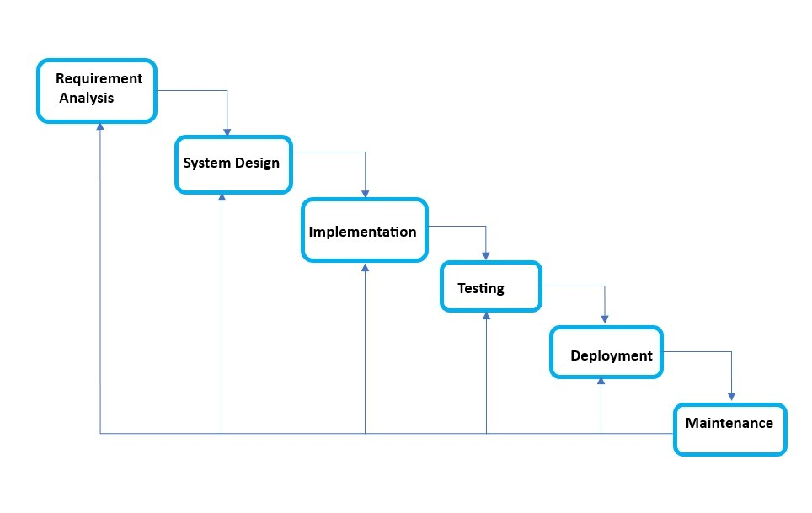
Figure 3.1 Waterfall Model

- Requirement Analysis:
This phase involved identifying the objectives of the quiz game, such as displaying multiple-choice questions, accepting user input, tracking scores, and saving high scores using file handling. The need for a simple, text-based interface was also determined here.
- System Design:
The game’s structure was outlined, including the flow of menus, question display, score calculation, and high score management. The data structures (like structs for storing questions and scores) were also planned during this phase.

- Implementation:
The game was developed using the C programming language. Modular coding practices were followed to divide the system into manageable parts like question loading, score tracking, and file operations.
- Testing:
The game underwent thorough manual testing to identify and fix bugs. This included checking input validation, question flow, file read/write operations, and the accuracy of score tracking.
- Deployment & Maintenance:
Once tested, the game was finalized for deployment on the terminal. Ongoing maintenance was considered to enhance the question set, improve code efficiency, and apply any feedback received during gameplay sessions.

3.2 Technologies and Tools Used

3.2.1 Programming Language Used
C Language:
Chosen for its low-level control and efficiency, C was ideal for developing a terminalbased quiz game. It enabled effective use of conditionals, loops, structured data (like structs), and file handling — all essential components for a smooth game experience in a console environment.

3.2.2 Database Used
File System:
Instead of a traditional database, the game uses a simple file system to store and retrieve high scores. This approach keeps the game lightweight and ensures that user progress or scores can persist across sessions without needing a complex setup.

3.2.3 Software Used
GCC Compiler
The GNU Compiler Collection was used to compile the C source code, especially suited for Linux environments.
Terminal/Console
The terminal functions as the game’s user interface, displaying menus, questions, and scores in a text-based format.

3.2.4 Integrated Development Environment (IDE)
VS Code
Used for writing and managing the C source code. It provides useful features like syntax highlighting, terminal integration, and debugging support through extensions.

3.3 Assignment of Roles and Responsibility
Member Name | Roles and Responsibility
Soviet Khaling Rai | Coding and documentation
Sagar Rai | System Flow chart
Saroj Karki | Algorithm

4 System Analysis
This chapter covers the analysis of the Quiz Game system in terms of its goals, requirements, and expected behavior. The analysis phase was crucial in determining what the system should do, how it should perform, and under what constraints. The focus was on identifying both functional and non-functional aspects of the game to ensure smooth gameplay, user engagement, and efficient resource usage.

4.1 Requirements Analysis
System analysis began with identifying the needs of the end user and translating those into precise technical requirements. The development was guided by the constraints of a console-based environment, real-time input handling, and simplicity of controls.

4.1.1 Requirement Gathering
The requirements were gathered through:
Requirement ID | Description
R1 | Studying similar console-based quiz and trivia games.
R2 | Understanding the limitations and possibilities of terminal applications.
R3 | Feedback from peers and instructors regarding features that improve user experience.
R4 | Personal goals such as including score tracking, question variety, and persistent high scores.

4.1.2 Functional Requirements
Functional requirements describe what the system should do. For the Quiz Game, the functional requirements are:
Function  ID | Functional Requirement | Description
F1 | Question Display | The system must display multiple-choice questions with options to the player.
F2 | User Input Handling | The player must be able to select answers using keyboard inputs.
F3 | Score Calculation | The system should calculate and update the player’s score based on correct answers.
F4 | Timer (Optional) | Implement a timer to limit the time for each question (if applicable).
F5 | High Score Saving | Save the highest score persistently using a file system.
F6 | Question  Randomization | Questions should be presented in random order each game session.
F7 | Instructions Menu | Display game instructions before starting.
F8 | Feedback System | Provide feedback on correct or incorrect answers after each question.

4.1.3 Non-Functional Requirements
Non-functional requirements describe how the system performs rather than what it does. These include:
Function  ID | Non-Functional Requirement | Description
F1 | Performance | The game should run smoothly without lag in real-time, even in low-resource environments.
F2 | Portability | It should be able to run on most Linux-based terminals without special hardware.
F3 | Usability | The interface should be intuitive, using clear text-based UI and instructions.
F4 | Maintainability | The codebase should be modular, allowing easy updates and enhancements.
F5 | Reliability | The game must handle unexpected inputs without crashing.
F6 | Resource Efficiency | Should consume minimal CPU and memory.

4.2 Gantt Chart
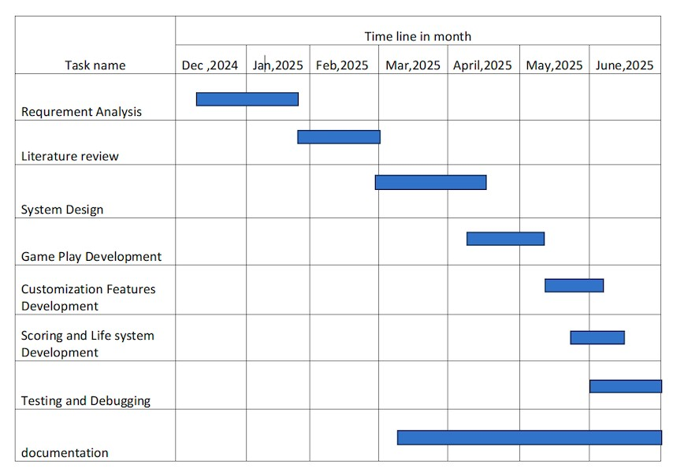

Figure 4.2 Gantt chart

5. System Design

5.1 System flow Diagram and Algorithm
This section explains the system architecture, design, and how the game operates.

5.1.1. System Algorithm
Step 1: Start.
Step 2: Display menu.
- Start quiz
- View rules
- Exit
Step 3: Initialize question counter and score.
Step 4: load questions of all category from file.
Step 5: for each questions.
- Display the questions and options.
- Get users input (A/B/C/D).
- Check if the answer is correct
  - If correct increment score
  - If wrong display incorrect
Step 6: Repeat until all questions are answered
Step 7: Display the final score
Step 8: ask if the user wants to play again
  - If yes repeat from step 4
  - If no exit from the game
Step 9: End

5.1.2. System Flowchart
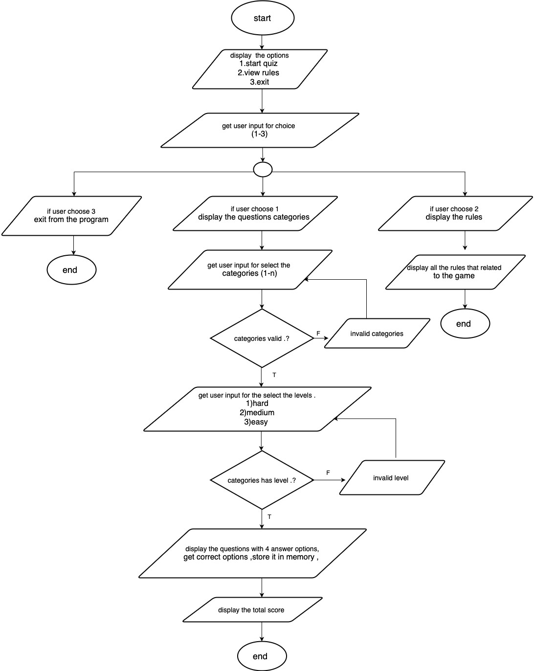

Fig 5.1.2 System Flow Diagram

6 System Development and Implementation
This chapter details the development process and the implementation environment of the Quiz Game. It covers the chosen programming platform, the setup required for smooth execution, and highlights the tools and technologies employed during the development phase.

6.1 Programming Platform
The quiz game was developed using the C programming language due to its efficiency and direct control over console input/output operations. The terminal-based environment allowed for straightforward handling of user interactions and game logic processing.

6.2 Operating Environment
The game runs on both Windows and Linux terminals, leveraging standard terminal commands and ANSI escape sequences for formatting text and clearing the screen. This setup ensures broad compatibility without the need for graphical libraries or additional dependencies.

\

7 Testing and Debugging
This chapter focuses on the strategies, tools, and methods applied to test and debug the Quiz Game, ensuring that the program functions correctly and efficiently

7.1 Tools Used in Testing

S.N | Tool | Specifications/Details
1 | Hardware | MacBook with Apple M1 chip, 16GB RAM
2 | Development Environment | GCC Compiler (Version 12.1), macOS Terminal
3 | Manual Debugging | Step-by-step code tracing, print statements for logic verification
4 | Manual Test | Console-based manual gameplay testing

7.2 Test Cases
ID | Test  Case  Name | Test Case Description | Test Case Data | Expected Result | Actual Result | Status
1 | Game Launch | Start the  game from terminal | Run executable | Game starts and displays intro screen | Game starts and displays intro | Success
2 | Question Display | Display a question with multiplechoice options | Load question data | Correct question and options displayed | Question and options displayed | Success
3 | Answer  Input | Input answer choice via keyboard | User input (A/B/C/D) | Input accepted and validated | Input accepted and validated | Success
4 | Correct  Answer Scoring | Answer question correctly | Correct choice | Score increments by 1 | Score increments by 1 | Success
5 | Incorrect  Answer  Feedback | Answer question incorrectly | Wrong choice | Display “Incorrect” feedback | “Incorrect” feedback displayed | Success
6 | End of Quiz | Complete all questions | All questions answered | Final score displayed | Final score displayed | Success
7 | High  Score  Saving | Save and load high score on  program  restart | Play quiz, quit, restart | High score loads correctly | High score loads correctly | Success

8 Conclusion
The Quiz Game project successfully demonstrates the implementation of a consolebased interactive quiz using the C language. It provides an engaging user experience with real-time input handling, instant feedback, and persistent scoring. The project enhanced understanding of user input processing, file handling, and text-based UI design in a resource-constrained environment.

9 References
- GeeksforGeeks, “C Programming Language,” https:// www.geeksforgeeks.org /.
[Accessed:20-Dec-2024]. [Online]. Available:
- OpenAI, “Quiz Game,” https://chat.openai.com/. [Accessed: 15-jan-2025].
[Online]. Available:

